Developing a Plug-in

**How to Start Developing a CRM Plug-in**

1. Set up your plug-in project in Visual Studio. This will be a .NET class library.

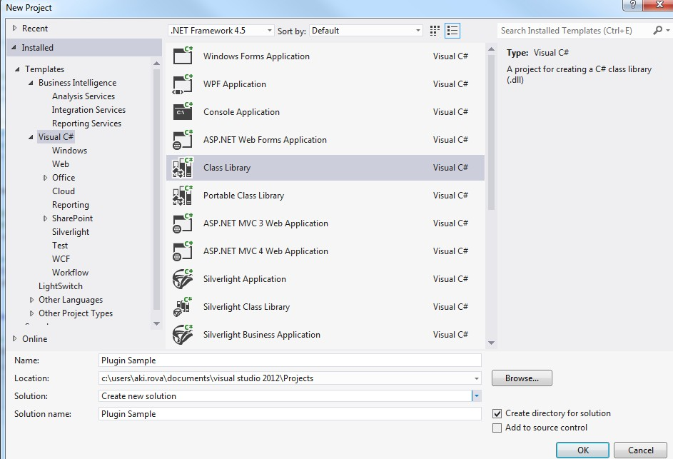

1. Add References –   
   Microsoft.CrmSdk.CoreAssemblies  
     
   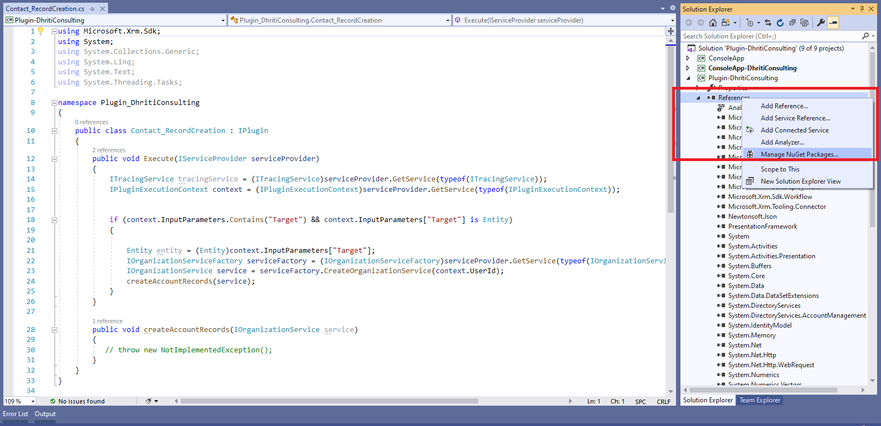
2. Extend the class from Microsoft.Xrm.Sdk.IPlugin
3. Write your code

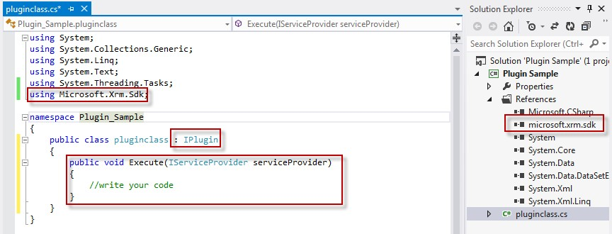

1. At the project, sign the assembly. This is required in order to be able to deploy the plugin.

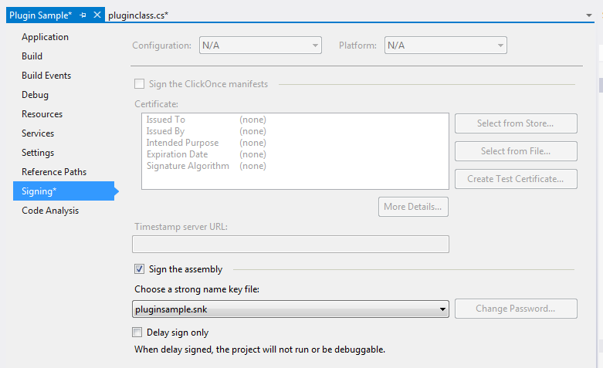

1. Compile the assembly and deploy using Plugin Registration Tool.

# Example 1: Code Execution on Record Creation

Here's an extremely simplified example of a plug-in. We have contact record and when a record is created by user, we need to fill in the information in description attribute that record has been created through Plugin

# Plug-in Code

using Microsoft.Xrm.Sdk;

using System;

using System.Collections.Generic;

using System.Linq;

using System.Text;

using System.Threading.Tasks;

namespace Plugin_DhritiConsulting

{

public class Contact_RecordCreation : IPlugin

{

public void Execute(IServiceProvider serviceProvider)

{

ITracingService tracingService = (ITracingService)serviceProvider.GetService(typeof(ITracingService));

IPluginExecutionContext context = (IPluginExecutionContext)serviceProvider.GetService(typeof(IPluginExecutionContext));

if (context.InputParameters.Contains("Target") && context.InputParameters["Target"] is Entity)

{

Entity entity = (Entity)context.InputParameters["Target"];

IOrganizationServiceFactory serviceFactory = (IOrganizationServiceFactory)serviceProvider.GetService(typeof(IOrganizationServiceFactory));

IOrganizationService service = serviceFactory.CreateOrganizationService(context.UserId);

createAccountRecords(service);

}

}

public void createAccountRecords(IOrganizationService service)

{

Entity contactRecord = new Entity("contact");

contactRecord["description"] = "Record created through plugin";

service.Create(contactRecord);

}

}

}